SEND Information Report


‘Let your light shine’

Linton CE Infant School Local Offer for SEND

Review date: September 2026

1. A Whole-School Inclusive Approach ………………………………p. 2
2. What are ‘Special Educational Needs’? …………………………..p. 2
3. Who can I talk to about my concerns? ……………………..………p. 2
4. Identification and Assessment …………………………………..…p. 3
5. A Graduated Approach to Support …………………………………p. 3
6. Monitoring Progress and Record-Keeping ………………………..p. 3
7. Key Policies and Documentation ………………………………….p. 4
8. Glossary of Useful Terms …………………………………………..p. 5

- A Whole-School Inclusive Approach
At Linton CE Infant School, we aim to foster an inclusive environment in which our children can grow and flourish. We have high expectations of all of pupils, and encourage ongoing communication and engagement with families so we can best support the children’s personal and academic development. We believe that children should be included in high quality educational experiences regardless of their needs, abilities, or backgrounds.

- What are ‘Special Educational Needs’?
Special Educational Needs (SEN) are those which present barriers to learning and may require support which is different from or additional to that provided for by good quality first teaching. A child or young person has SEN if they have a learning difficulty, disability, or neurodivergence which calls for special educational provision to be made for them. The Special Educational Needs and Disability Code of Practice: 0 to 25 years (DfE, 2015) outlines four core areas of need, however a child may experience difficulties in one or more of these areas.
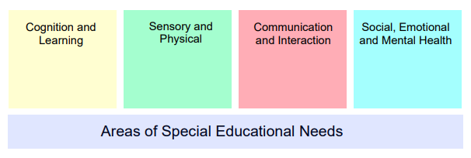

Figure 1. The core areas of Special Educational Needs according to the Code of Practice (2015)

- Who can I talk to about my concerns?
If you feel concerned about your child’s educational progress or barriers to their learning, please do speak to their teacher as a first point of contact. Teachers are contactable via Class Dojo or by leaving a message with the school office on 01223 891 421.
If you require further support please do get in touch with one of the following people:
SEND governor: Reverend Michael Wilcockson
mwilcockson@linton-inf.cambs.sch.uk
Headteacher: Mrs Kelly Harries
head@linton-inf.cambs.sch.uk
Special Educational Needs and Disabilities Coordinator (SENCo): Miss Stephanie Booth
sbooth@linton-inf.cambs.sch.uk

- Identification and Assessment
Our Early Years team work closely with staff at the local preschools to ensure a smooth transition into Reception. Children may be visited and observed in their preschool setting as part that early identification of need, and plans may be written to support their move to school.
As your child moves through the school, teachers will continually assess and monitor their progress across all areas of learning. Throughout Reception they are assessed against the Early Years Framework and in Key Stage 1 assessed against the National Curriculum expected levels. They may use a range of methods to assess children’s levels, including reading levels, phonic assessment data, observation, and professional judgement to identify potential areas of difficulties or concern.
Specialist assessment methods such as the Strength and Difficulties Questionnaire (SDQ), the Practitioner Development Journal (PDJ, 2013) and other assessment tools may be employed by the SENCo or external agencies.
Pupil Progress Meetings
Each half term the Headteacher, SENCo, and class teachers meet to review the progress of the children in that class, as well as discussing any potential barriers to learning or specific needs within the class. In these meetings, we will discuss current provision and support within the classroom and consider any changes that may need to be made to support particular children. The impact of any provision is monitored to ensure its effectiveness and suitability for that child.
At times, the school may request further support or advice from a range of external professionals. The SEND 0-25 service, Speech and Language therapists, and Emotional Health and Wellbeing service are all sources that we may draw upon to ensure the best possible support for your child.

- A Graduated Approach to Support
We follow the Graduated Approach as set out in the Code of Practice (2015) in which the level of support for children with identified SEND increases if adequate progress has not been made over time or new identified needs arise. Please see our SEND policy for more detail about the different levels of support.

Here at Linton CE Infant School we believe that high quality, accessible and inclusive teaching is key to ensuring children’s progress regardless of their background, prior experiences, or neurotype. By drawing upon a range of evidence-based interventions and strategies as well as continually developing neurodivergence-friendly environments, we aim for fully inclusive classrooms in which all children can thrive not just survive.

- Monitoring Progress and Record-Keeping
When a child is added to the school SEN register, a Personal Plan (individualised education plan/IEP) is written for them.
This will include:
• A One Page Profile = an overview of the child’s likes and dislikes, what they find difficult, and things people like about them
• A Provision Map = detailing what additional or different support is in place for the child throughout the school week
• Cycles of Assess, Plan, Do, Review = personalised targets which will be reviewed and updated throughout the year by the class teacher in discussion with parent and child (may not be appropriate for certain medical needs)
Individual targets will be set and reviewed at termly review meetings with parents, following an Assess, Plan, Do, Review cycle. Where possible, the child will be involved in this process and adaptations can be made to enable them to take part in discussions about their own learning and provision. Personal plans are written collaboratively by class teachers and the SENCo, and monitored termly by the SENCo.
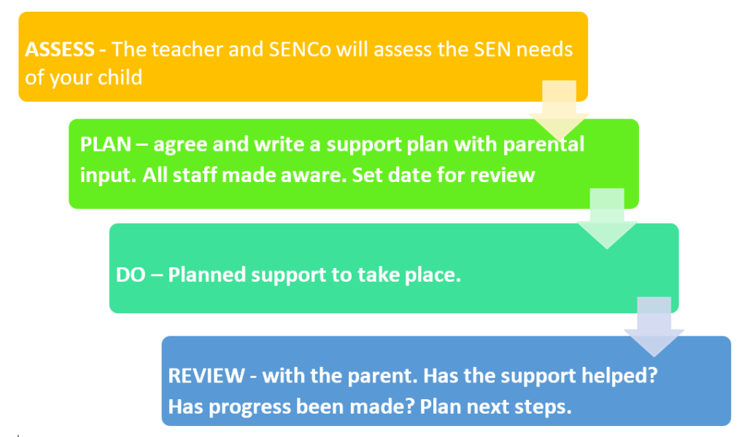

Figure 2. The Assess, Plan, Do, Review process

- Key Policies and Resources
Code of Practice (2015) – https://www.gov.uk/government/publications/send-code-of-practice-0-to25
Children and Families Act (2014) - http://www.legislation.gov.uk/ukpga/2014/6/contents/enacted
Equalities Act (2010) - http://www.legislation.gov.uk/ukpga/2010/15/contents
Cambridgeshire Council Local Offer - www.cambrigeshire.gov.uk/SEND
SEND Information, Advice, and Support Service (SENDIASS) - https://send.cambridgeshire.gov.uk/kb5/cambridgeshire/directory/site.page?id=MR9QIFVa_9Q
Pinpoint, SEND parent and carer support - https://www.pinpoint-cambs.org.uk/

- Glossary of Useful Terms

Term | Definition
APDR | Assess, Plan, Do, Review  The process of continued monitoring of child’s progress
ASC/ASD | Autism Spectrum Condition/Autism Spectrum Disorder
CAMHs | Child and Adolescent Mental Health Service
CHUMS | Mental Health and Emotional Wellbeing Service for Children and Young People
EHA | Early Help Assessment  This referral goes to the Early Help Hub and requests support for the child and family
EHC/EHCP | Education Health and Care (Plan)  This is what replaced the old ‘statement’ system, in which a child has a plan which states the specific provision they require from Educational, medical, and social care perspectives
EHWS | Emotional Health and Wellbeing Service
Personal Plan | The document written for a child on the SEN register
SALT | Speech and Language Therapy/Therapist
SEMH | Social, Emotional and Mental Health
SEN/SEND | Special Educational Needs (and Disabilities)  Areas in which a child may require additional support or alternative provision
SEN register | A record of all the children with SEN in the school
SENCo | Special Educational Needs Coordinator
TA | Teaching Assistant

