Maths in EYFS at Linton Infants
Maths is everywhere, every day and in early years it is hard to find any aspect of play and learning that does not include an element of mathematical development.
Maths is very diverse and includes topics such as number, money, time, shape, distance, the list goes on. Maths is real life and we all use it every day without always even realising.

In EYFS we plan to deliver many specific taught sessions to develop all aspects of mathematical development however these are often only short sessions and are very hands on using real objects to solve problems and learn about all the different aspects of mathematics. The large majority of our maths teaching is led through the activities and provision within the classroom and staff members actively joining in play to help continue to develop mathematical understanding.
For example this could be supporting the children playing and building with the large wooden building blocks and initiating discussions about the shapes and sizes or the numbers of blocks the might need to complete the model.
Another example could be creating a throwing game, allocating points to the targets and calculating the total scores.

As part of our assessment in EYFS maths is split into 2 Early Learning goals: Number and Numerical Patterns

Early Learning Goals for Mathematical development. (ELG)
The table below shows the Early learning goals that we assess the children against at the end of the Early years foundation stage. This is at the END of the reception year and there are many smaller mathematical stepping stones that should have been planned for and achieved prior to reaching to these goals.

Number ELG | Numerical Patterns ELG
- Have a deep understanding of number to 10, including the composition of each number;  - Subitise (recognise quantities without counting) up to 5;  - Automatically recall (without reference to rhymes, counting or other aids) number bonds up to 5 (including subtraction facts) and some number bonds to 10, including double facts. | - Verbally count beyond 20, recognising the pattern of the counting system. •  - Compare quantities up to 10 in different contexts, recognising when one quantity is greater than, less than or the same as the other quantity.  - Explore and represent patterns within numbers up to 10, including evens and odds, double facts and how quantities can be distributed equally

Subitising
Subitising is key to supporting children in becoming fluent in being able to use number and use their knowledge to effectively solve problems and tackle maths activities. Subitising is the ability to look at a small number of objects and instantly recognise how many objects there are without needing to count.
We do lots of activities to develop this skill. We notice many of our youngest children can quickly recognise 3 objects without counting and this skill quickly develops the more they get used to spotting numbers ‘Don’t count, say the amount!’
Say it, Build it, Draw it and write it
As children go through reception and into year 1 and 2 the methods of say it, build it, draw it and write it are used through many maths activities.

Say it
- Counting out loud – backwards and forwards
- Singing number and shape songs
- Using actions when counting out loud – such as clapping. This helps the children to understand the one to one correspondence in counting i.e. each object is one more thing.
- Using different voices to count out loud, rockstar voice, whisper, alien voices to add a bit more interest!
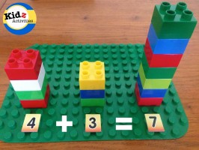
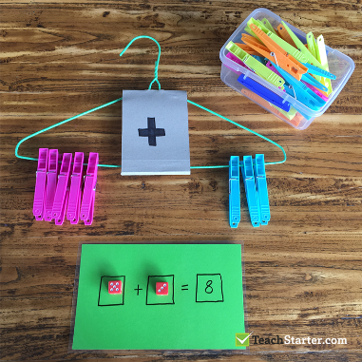
Build it (show it)
- Use toys and models to represent numbers and quantities
- Use construction toys to show calculations such as Lego
- Use everyday objects to represent number and calculations such as pegs, chocolate buttons, cars… anything!

Draw it
- Drawing objects/pictures to represent numbers
- Writing numerals
- Drawing shapes
- Drawing objects to solve problems – adding, sharing, taking away, grouping

In reception this would not necessarily include using formal symbols and although the (mathematical operation) symbols of + - = x and ÷ might be modelled where appropriate there is not an expectation that the children will use or recognise them. Our activities focus more on developing the children’s understanding of the concepts of addition, subtraction, division and multiplication.

Write it
- Writes numbers that are important to the children
- Writes sequences of numbers
- Writes numbers for labels – for example in play the children write labels for seat numbers in their play cinema
- Recording numbers as messages for example, telephone numbers, price labels, and appointment times in role play.
- Whilst ‘write it’ might include writing some number sentences i.e. 4 + 2 = 6 this is unlikely to appear very naturally in play and will often be part of a more formal session. The importance in placed more on the children’s understanding of the concepts.

Data Handling
Although not specifically mentioned in the Early learning Goals data handling is a fun way to encourage children to look at numbers, find out what they mean and consider what the number information tells them. For example the children could ask their families to try 5 different flavours of crisps and ask them to decide which one they like most, the information that the children get back helps them to explore concepts such as more and less and can help them to make decisions. The programme 2count on purple mash is designed to create pictograms to help the children to record information like this too.

Number songs
There are many songs that support counting as well as addition and subtraction. Songs such as 5 little Ducks and 5 Little Monkeys jumping on the bed reinforce what happens when one is taken away, similarly 10 green bottles will do the same thing. These songs can be adapted to start with different numbers.

Shape, Space and Measure
This is a huge area of learning that includes many different aspects of maths all of which can be explored through day to day routines and play.
- Size
- Weight
- Capacity
- Position
- Time
- Money
- Distance
- Shapes
- Patterns
These concepts can all be taught, and will naturally occur, through play.

Construction play
Building and constructing with toys such as Lego will explore shapes and sizes and encourage the children to make comparisons. Is the tower shorter or taller than mummy? Building will encourage chn to talk about the positioning of their models.

Messy play
Playing with resources such as play dough, clay, gloop, water, sand, mud and anything else messy can lead to lots of learning about weight and capacity as well as other concepts such as shapes and patterns. Children will naturally want to explore patterns in the environment and find out what they can do with resources, what happens if I press Lego into play dough? How much water can I fit into this tub? All questions that will encourage the children to think mathematically.

Role play
Children imagining themselves in different roles leads them to use maths in different ways. The children will enjoy playing in roles such as shopkeepers, café owners and mums and dads. They will open cinemas and put on shows leading to the need to make tickets and seat numbers. Often role play will involve money and children love nothing more than to charge extortionate amounts in their cafes and ice cream shops. This play allows them to explore money in a meaningful context and will encourage them to count out, recognise coins and use number vocabulary.
Shoe shops and clothes shop play encourages children to think about size and shapes and whether things are big or small enough.
This type of play will encourage children to use vocabulary to describe times, making appointments in their role play hairdressers

Children develop more understanding of these concepts whilst being able to explore them confidently in their own play. Their use of mathematical vocabulary will increase as they become more confident with concepts.

Physical Play
Physical games and activities will enable children to explore time through using resources such as stop clocks to maybe take part in activities such as one minute challenges, how many star jumps can you do in one minute? The children can explore making patterns with their bodies such as musical patterns for example clapping and stamping to make repeating patterns. Children can make shapes using their bodies and physical games and activities will help them to think about and understand position.
Games such as Simon Says can be great for helping children to understand maths vocabulary – Simon says put your hands on top of your head. Simon Says jump 5 times.

Games and Puzzles
Jigsaws help children to see shapes and patterns, develop spatial awareness, matching, sorting and problem solving. Games are an excellent way of using maths in play. Games such as snap, pairs, snakes and ladders, Uno and others have key features of both number and shape, space and measure. Children don’t need to have the newest games out but can make up their own board games with simple grids and using whatever they can find for counters. Dice games are hugely valuable and if a child can be involved in creating their own their will also be motivated by being able to create their own rules for the game which often get more elaborate as the children’s cunning thoughts to make sure they win take over!

Junk Modelling and craft
Children need to use their understanding of shapes and sizes to create using junk modelling. Through junk modelling the children explore the features of both 2D and 3D shapes and use them with purpose. Size, weight and capacity are also explored through junk modelling and craft activities.

Block play
This is one of the most popular areas in the classrooms and children love to build and create with the wooden blocks. Wooden blocks are not designed to deliver any pre-conceived ideas. They are blocks that can be turned into anything. Children love to build models and cities as well as just make patterns and explore concepts such as balance and symmetry. The designs become more and more intricate and we see patterns emerging in the most elaborate buildings.
Blocks and planks make brilliant ramps and enable children to investigate other concepts such as rolling and sliding, features of some 3D shapes. The children will be curious to find out how far cars might travel and make adaptions to see if things will move faster and slower.

Books and stories
There are many different stories that help to support mathematical development and vocabulary. Traditional stories such as The Three Little Pigs and Goldilocks explore both numbers, shapes, and sizes. Below is a list of a few books that are really useful in exploring different elements of maths
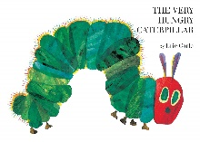The Very Hungry Caterpillar by Eric Carle - Numbers, days of the week
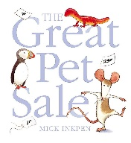 The Great Pet Sale by Mick Inkpen – Money, size
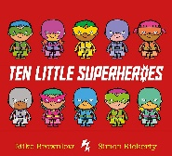 Ten little superheroes by Mike Brownlow – Counting, subtraction
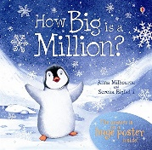 How big is a Million by Anna Milbourne– numbers, quantity
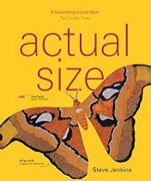 Actual size by Steve Jenkins – size comparison
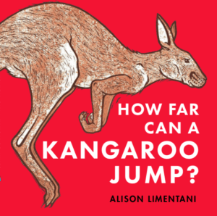 How far can a Kangaroo Jump? By Alison Limentani- size, measure, distance
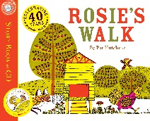 Rosie’s walk by Pat Hutchins – positional and directional language
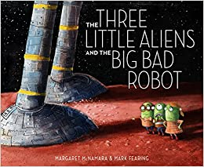 The Three little Aliens and the Big bad robot – A alternative version of The Three Little pigs
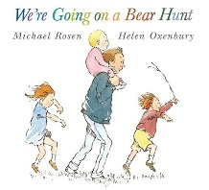We’re going on a Bear Hunt by Michael Rosen – positional directional language
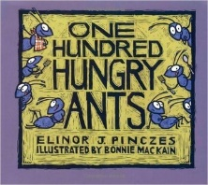 One Hundred Hungry ants by Elinor Pinczes – big numbers, division and multiplication

Every day activities and routines
There are a huge amount of everyday activities and routines which will support the children’s understanding of a wide range of mathematics.
Cooking together explores weights, measure and capacity.
Setting the table – have you got enough plates, cups, knives and forks etc
Bath time will bring lots of opportunity to explore capacity if the children can have tubs and bottles to play with.
Routines to the day helps support children with the concept of time.
Sorting the washing – grouping, sorting, and pairing socks!
Walks out and about – spot big and small things, explore distance, direction, position and find numbers when out and about.

Maths in the natural world
Nature has an excellent way of helping us out and it is no different with maths. Natural patterns can be seen everywhere if we look closely. From the symmetrical patterns on a butterfly and the intricate shapes created by bees building their nests to spirals found on snail shells and counting seeds out of a sunflower head. Encouraging children to spot maths in nature is another great way of building skills and knowledge.

Key Equipment and resources
Although there are many resources that are marketed specifically to support children’s mathematical development the truth is that the majority of learning mathematically can be done just as well (if not better!) with natural and everyday objects and using things that we find everyday makes maths more meaningful. Where maths is only taught through specific maths resources it might start to appear to children as a subject that we ‘do’ rather than skills that are integral to everyday life.
Whilst you might be tempted to look at resources to support maths take time to consider what the resource is offering that can’t be achieved by something else you already have at home. For example, does a set of pattern matching cards offer anything different to being able to mix up all the socks and find the matching pairs?

Key Messages
Maths is everywhere
Maths happens every day
Maths should be real and meaningful
Maths is integral to our world and lives
Maths is fun!

